Aucotec Management Board is restructuring
New management structure, new head office, proven strategy
Press release
Tuesday, 12 December 2017
Hanover: on 1 April 2018, the Management Board of the engineering software specialist Aucotec will be streamlined from three to two people. After 25 years in the software industry, Markus Bochynek (51), who was responsible for Sales and Marketing for almost ten years, wants to pursue new challenges in a new area.

Growth by focusing
"All of us, including Markus Bochynek, view this farewell with mixed feelings," said Aucotec's CEO, Horst Beran (75). "For as much as we regret his departure after such a long and successful collaboration, the timing is perfect." In almost ten years, Aucotec AG has undergone a paradigm shift with respect to product strategy, which has led to six consecutive years of sales records, with a total growth of over 80%. Aucotec has increased the number of its employees by around 35%. By the end of October, the orders received had increased by 20% compared to 2016.

"With the change of focus from several product lines to the Engineering Base (EB) platform, which covers our two main directions in terms of plant and mobility solutions, Aucotec is very clearly positioned for the future. And we will continue along these lines," said Horst Beran. In the course of this growth, the company established a new management structure and culture, which now manages very flexible and cooperative teams.

New Management Board team
"We have the Board team Uwe Vogt and Markus Bochynek to thank for all of this," explained the CEO and emphasized: "The stable structure and orientation that we have achieved means that all strategic decisions and management tasks no longer have to originate at Board level."

In light of the above, Management Board member Uwe Vogt (48) will also assume responsibility for Marketing and Global Sales. Vogt, who has been a member of the Management Board team since 2009, has already managed the areas of Research and Development, Consulting and Service. As co-founder and one of the main shareholders of Aucotec, Beran will continue to preside over the Management Board and will be responsible for the Finance sector. Beran and Vogt will jointly manage the company, which has been independent for the last 32 years. The existing management team below the Management Board will assume some of the previous responsibilities and tasks of Vogt and Bochynek. "The Supervisory Board has fully agreed to this," said Beran.

Construction of Aucotec's head office
For the coming financial year, Beran made an advance announcement about a special project: "We are planning a new head office that will meet our growth. Its construction will start next year." Markus Bochynek will be invited to the inauguration in any case. He has said that he will remain closely connected to the company.

Links to the images*:

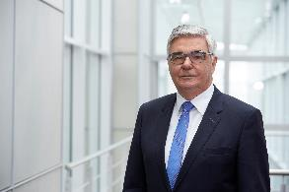
Horst Beran, Chief Executive and Chief Financial Officer of Aucotec AG (© AUCOTEC AG)

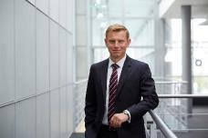
Uwe Vogt, Aucotec Executive Officer with a new area of responsibility (© AUCOTEC AG)

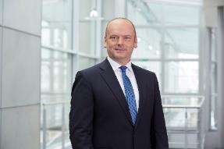
Leaving the Aucotec Management Board on 1 April 2018: Markus Bochynek (© AUCOTEC AG)

*These images are protected by copyright. They may be used free of charge for editorial purposes in connection with Aucotec.

If printed, we would appreciate receiving a copy. Thank you very much!
AUCOTEC AG, Oldenburger Allee 24, 30659 Hannover, www.aucotec.com
Press and Public Relations, Johanna Kiesel (jki@aucotec.com), +49 (0)511 6103-186

___________________________________________________________________________
Aucotec AG has over 30 years of experience in developing engineering software for the entire lifecycle of machines, plants and mobile systems. The solutions range from flow diagrams via control and electrical engineering for large-scale plants to modular harness design in the automotive industry. Aucotec software is in use all over the world. In addition to its headquarters in Hanover, Aucotec operates six further sites in Germany as well as subsidiaries in China, South Korea, France, the United Kingdom, Italy, Austria, Poland, Sweden and the US. A global network of partners ensures local support throughout the world.

