27 September 2016

Press release

This much is certain: changes in the "single source of truth"
Aucotec at SPS IPC Drives 2016 in Nuremberg

Aucotec's trade fair presentation at this year's SPS IPC Drives will focus on a new overall concept for change management in engineering. Particularly for modern simultaneous cooperative projects in Industry-4.0-compliant engineering, changes are a huge challenge: the more complex the project, the riskier its implementation. The system developers' solution is based on the database-driven nature of their Engineering Base (EB) platform which, as a "single source of truth", eliminates object duplicates, multiple entries, and transmission errors. In addition, the central data model ensures clear change tracking and extraordinary consistency.

Automatic comparing, tracking, adopting
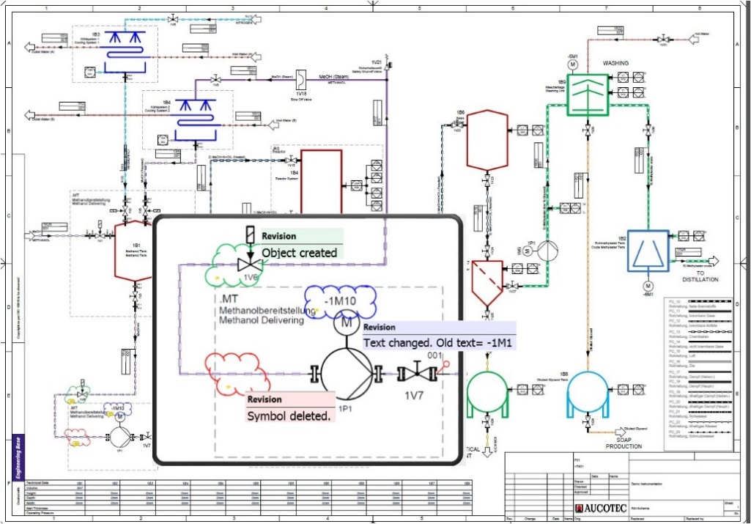
The new concept ranges from easy configurable data tracking for the perfect tabular project overview – also involving multiple subcontractors – via automated graphic revision up to detailed status tracking not only of objects, but also of individual attributes. These also include smart worksheets whose data is entered by contractors and is then automatically adopted and compared by EB. Changes are immediately visible. Initial pilot customers are already using the next level in which it is possible to define in a workflow-based manner the specific subsequent processes that are to be triggered when transitioning from one status to the next.

It is possible to filter specifically for different statuses. EB automatically detects and identifies changes in graphic documents, while tooltips show the previous status. Furthermore, the data-centric system makes the adoption of modifications during commissioning and maintenance more secure, offline as well as in online editing.

No more confusion, mistakes, omissions
With the growing number of increasingly comprehensive projects which are globally edited and involve many disciplines, contractors and subcontractors, one thing applies more than ever: nothing is more certain than change. "It is a rather uncertain thing to plan, oversee and consistently implement without a 'single source of truth'," said Reinhard Knapp, Senior Product Manager at Aucotec AG. "Subsequent changes are forgotten, the status is not identified correctly, revision statuses are confused, older versions are inadvertently imported or new statuses are not checked. This can be significantly optimized by EB." More certainty in relation to changes results in more reliable plant data. The decisive factor in this case is that everyone involved now has continuous access to all project data via the central data model, without system disruptions and lengthy comparison runs, or the previous complicated storage in file systems.

Aucotec at SPS IPC Drives 2016: Hall 6, Stand 110

Links to the images*:
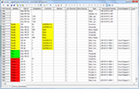
Delta Worksheet for „Advanced Data Tracking“ in Engineering Base (© AUCOTEC AG)

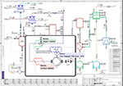
Graphical Revision in Engineering Base (© AUCOTEC AG)

Reinhard Knapp, Director Product Management, Aucotec AG (© AUCOTEC AG)

*These images are protected by copyright. They may be used only for editorial purposes in connection with Aucotec.

If printed, we would appreciate receiving a copy. Thank you very much!
AUCOTEC AG, Oldenburger Allee 24, 30659 Hannover
Press and Public Relations, Johanna Kiesel (jki@aucotec.com) +49 (0)511 6103-186

___________________________________________________________________________

Aucotec AG has over 30 years of experience in developing engineering software for the entire life cycle of machines, plants and mobile systems. The solutions range from flow diagrams via control and electrical engineering for large-scale plants to modular harness design in the automotive industry. Aucotec software is in use all over the world. In addition to its headquarters in Hanover, Aucotec operates six further sites in Germany as well as subsidiaries in China, France, the United Kingdom, Italy, Austria, Poland, Sweden and the US. A global network of partners ensures local support throughout the world.

