23 August 2016

Press release

Changing digitally with the system
More process reliability during system circuit diagram changes

at this year's international suppliers fair for the automotive industry, IZB, the Hanover-based software system supplier Aucotec AG will be introducing its new change management for the harness design development process. A core issue is digital change documentation which significantly improves comprehensibility and process reliability.

Designers must implement the inevitable changes made to the superordinate system circuit diagram (SYS plan) of a vehicle during the ongoing development process in the actual wiring diagram (KAB plan), which provides specific detailed about wires, plugs, splices, etc. to production. Instead of the usual manual change sketches and time-consuming discussions, corrections and changes can now be made in change mode and forwarded digitally just by clicking. The documentation contains administrative information, for example, date and those responsible and, if necessary, snapshots of the modified parts of drawings with changes marked. It also enables a clear "before" and "after" comparison to be made.

The new procedure, which is significantly more efficient and more correct, is also an essential precursor to the next step, which will allow the direct importing of changes into the KAB plan. Aucotec's developers are already working on this next step.

Aucotec at IZB Fair 2016: booth 3501, hall 3

Links to the images:
These images are protected by copyright. They may be used only for editorial purposes in connection with Aucotec.

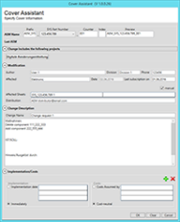
Assistant to fill in the change notice’s administration information (© AUCOTEC AG)

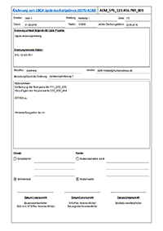
Cover of the change notice with necessary administration information (© AUCOTEC AG)
Comparison of the data before and after a change:
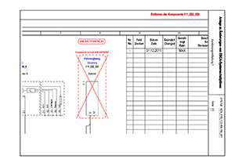
Change notice with marked original component in SYS plan (© AUCOTEC AG)

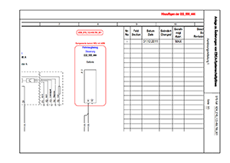
Replaced component in SYS plan change notice (© AUCOTEC AG)

If printed, we would appreciate receiving a copy. Thank you very much!
Aucotec AG, Oldenburger Allee 24, 30659 Hannover, www.aucotec.com
Press and Public Relations, Johanna Kiesel (jki@aucotec.com), +49 (0)511 6103-186

___________________________________________________________________________
Aucotec AG has over 30 years of experience in developing engineering software for the entire life cycle of machines, plants and mobile systems. The solutions range from flow diagrams via control and electrical engineering for large-scale plants to modular harness design in the automotive industry. Aucotec software is in use all over the world. In addition to its headquarters in Hanover, Aucotec operates six further sites in Germany as well as subsidiaries in China, South Korea, France, the United Kingdom, Italy, Austria, Poland, Sweden and the US. A global network of partners ensures local support throughout the world.

